Circassian Dance

АДЫГЭ КЪАФЭ

Amjad Jaimoukha

Dancing has always had a special place in the life of the Circassians. In mythical times, the Narts held annual festivals and tournaments in which dances were held. No public or family festivity was complete without a round or more of dancing. It also kept the male dancers in tip-top shape thanks to the energetic tunes. It is nowadays the most popular kind of folk art.

Dance was initially a religious rite, a kind of spirited prayer. Later it turned into a form of festive celebration, keeping some of its ritual significance. It was only in recent times that dance turned into a pastime devoid of religious meaning. All dances are based on the rich material of Circassian folklore. Cossacks, Georgians and other Caucasians adopted many Circassian dance forms and some melodies.

In general, women’s movements were graceful and reserved, no wild movements being required or displayed. The new generation of female ‘sedate’ dancers sometimes seizes the opportunity in informal sessions to show off vigorous moves, in parody of their male colleagues. In one modern comical choreography, gender-bending females perform acrobatic feats, strictly masculine affairs, with flourish. In borrowed dance forms, say the ‘Dance of Daghestani Lasses,’ some dizzying footwork gets the audience gasping for breath, never mind the dancers.

Dance as a religious ritual

It was believed that performance of special rites of worship in which supplicants encircle a venerated object, like a holy tree, or a spot stricken by lightning, invoked the resident spirits and unlocked their latent powers. Some accounts tell of solemn processions round a tree with the supplicants carrying torches. These formed a significant part of a complex system of prayers. The most sacred class of dances was called «удж (хъурей)» [wij (x’wrey)], which was performed by dancers forming a circle round a venerated object. It later turned into a dance performed by couples with music, losing all religious significance. A special dance consecrated to the supreme god, «Тхьэшхуэ удж» (Theshxwe wij) [Wij of the Supreme God], was executed with the bodies of the participants in compact formation. It was revived recently, but merely as a dance form.

Religious rites were sometimes accompanied by chanting. Songs were intoned during feasts in honour of thunder, during sacrifices and other pagan festivals. When lightning struck a place or an object, a special kind of «удж» (wij) was performed round the stricken spot accompanied by «Щыблэ уэрэд» (‘Schible Wered’)––‘Song of Lightning.’

Generic ritual

The rites of worship of Theghelej (Тхьэгъэлэдж), God of flora, had people of both sexes gather in the early hours of the day and start on a procession to the local sacred grove. They took with them an ample supply of victuals and a number of sacrificial animals. Festivities started when they entered the ancient wood. An effigy of the deity in the shape of a cross was placed near one of the most venerated trees in the wood. Prayer chants were intoned in single voice and chorus. The men and women formed a circle round the idol and the sacred dance, wij, was performed solemnly in much the same way it is done today. Couples moved round the icon holding hands, with music and chant in the background. When the effigy had been circumambulated a few times, a new formation was assumed in which all partakers in the dance faced the icon holding hands and lifting them periodically in supplication.

Prayers were then taken up by the priest, usually the eldest person in the group, who delivered a sermon that included a homily and thanksgiving for blessings rendered by the god. Next the rite of thelhe’w took place. The idol was presented with many culinary offerings, including makhsima, the national beverage. Animals, such as bulls, rams, lambs, ewes, and goats, were then sacrificed in front of the idol for the purpose of propitiation and propagation of bliss. The priest then distributed the flesh among the worshippers, not forgetting the ill and the poor who were unable to attend. The slaughtered animals were then cooked and feasted upon. The occasion merged solemnity with merry-making in a natural and healthy manner.

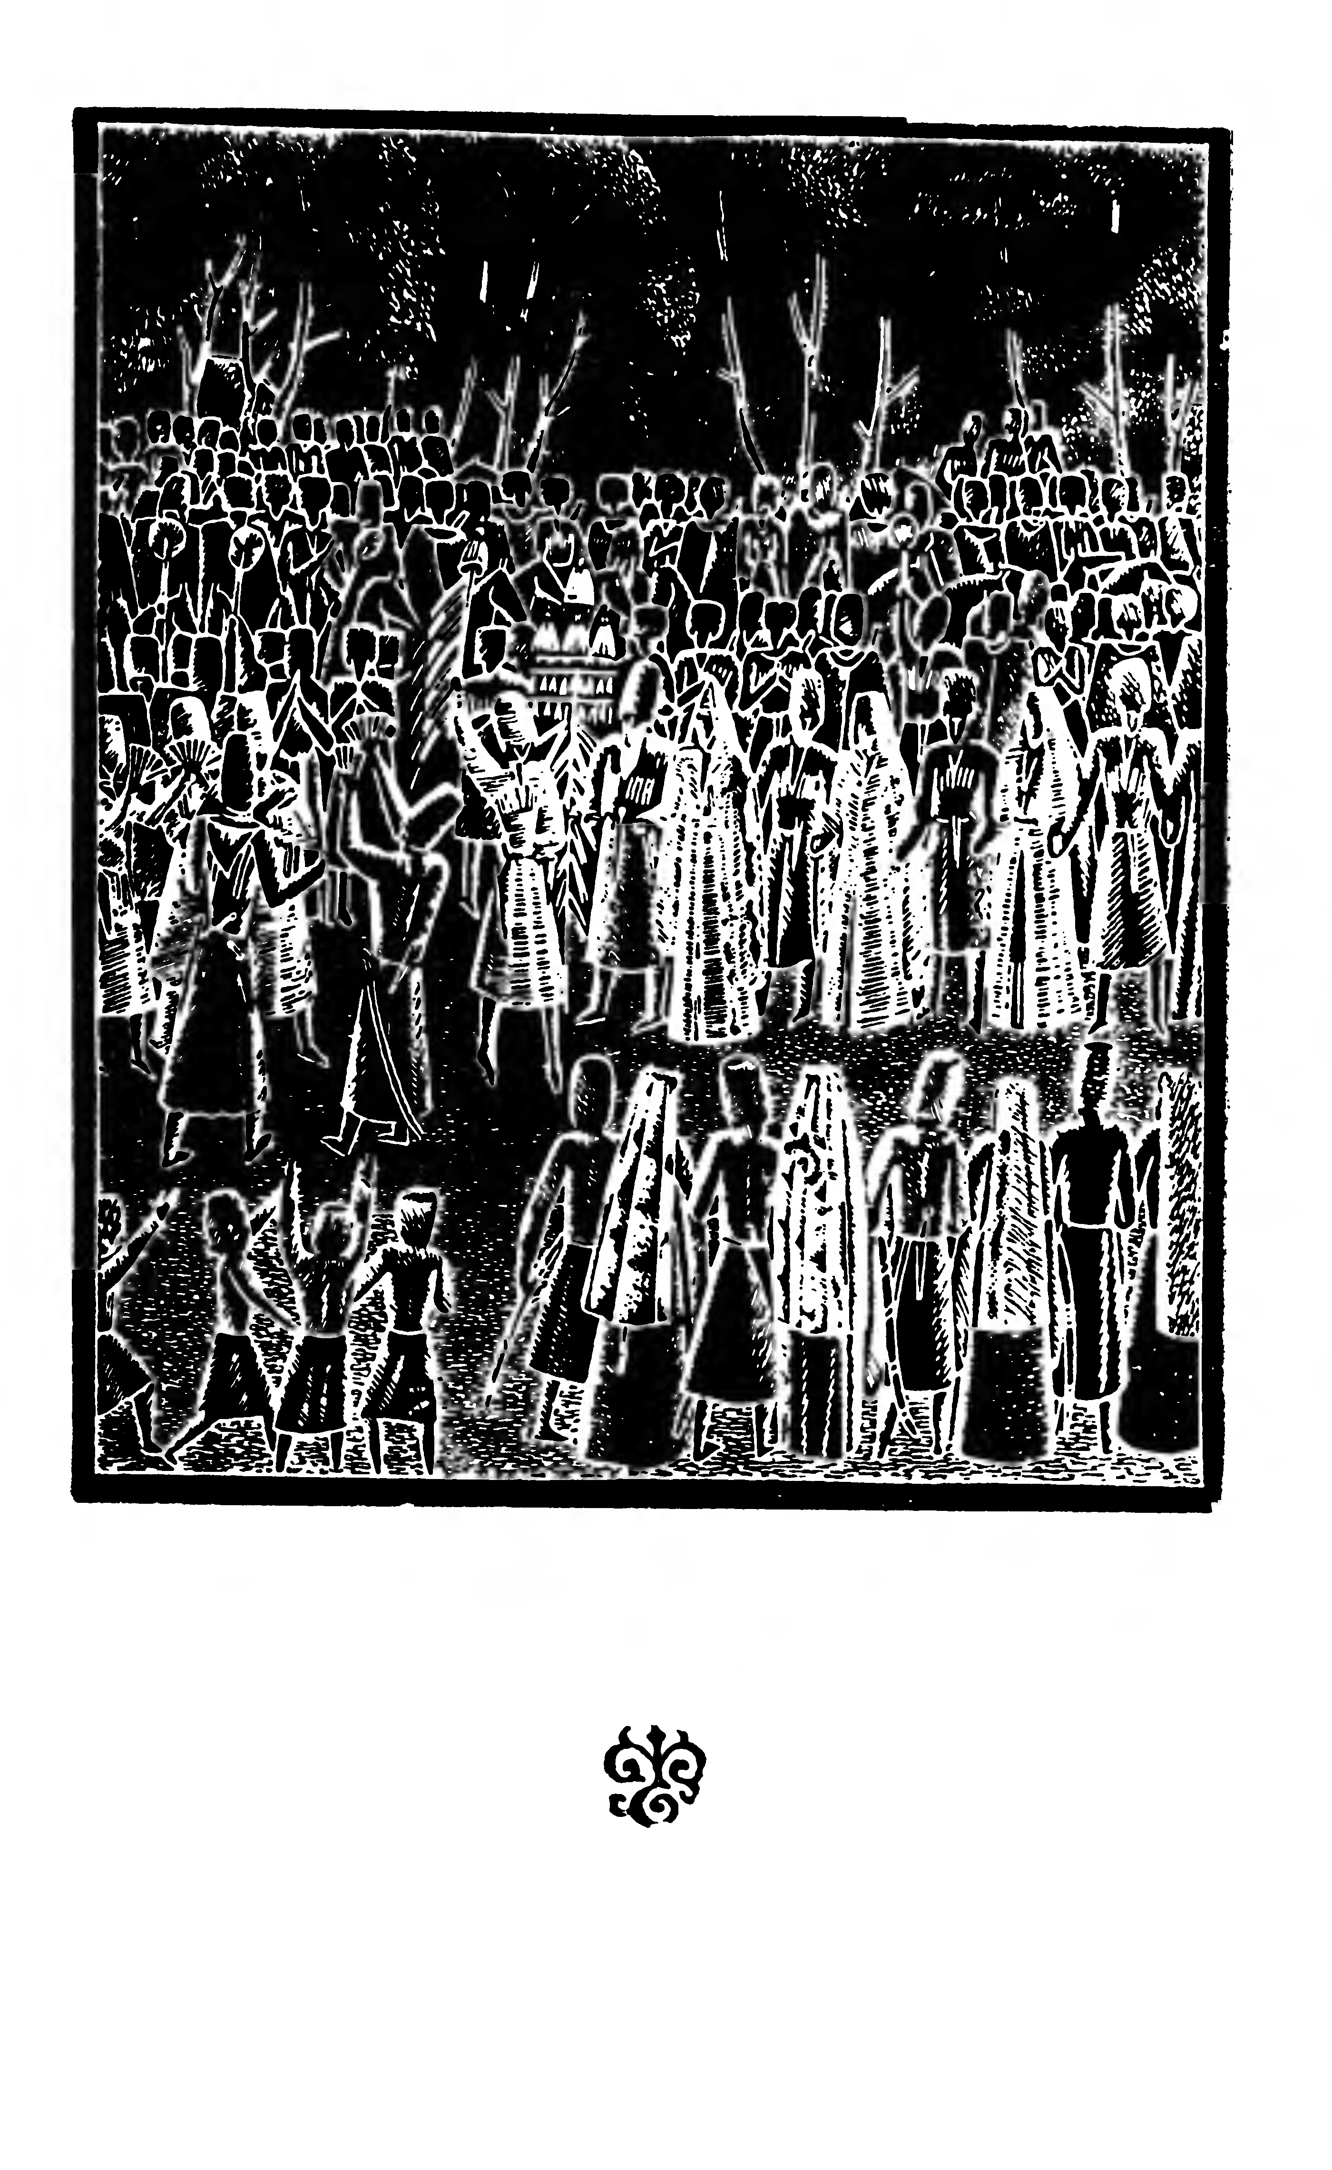
Depiction of generic festive ceremonies.
No matter what the occasion, activities, such as dance,
horse racing, shooting, gaming, were constant staples.

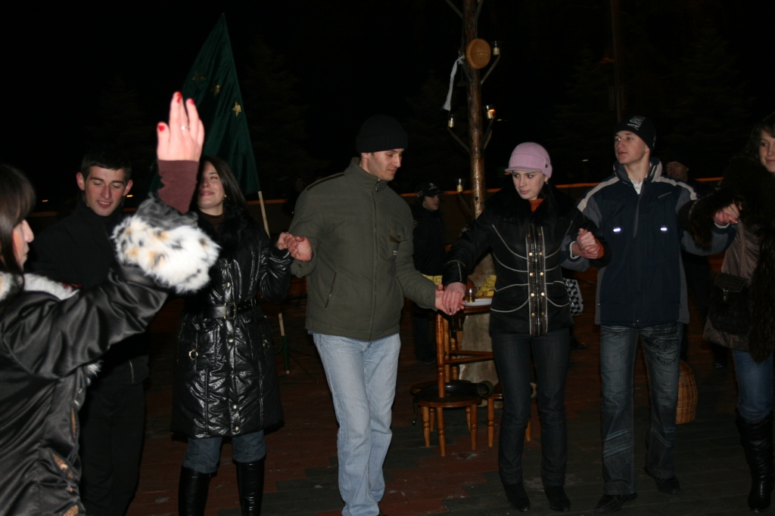
Modern-day Circassians celebrating the Birth (or Return) of the Sun (дыгъэгъазэ; Digheghaze) on 22 December 2007 in Nalchik. This is the time when the sun reaches its lowest apparent point in the sky and starts to rise up, a propitious occasion for an agrarian-pastoral society. This is one of a number of pre-historic festivals that have been resurrected in the new millennium. The pole in the background is the principal emblem of this celebration. The round loaf of bread high on the pole is an ancient folkloric depiction of the sun-god.

Kinds of Circassian Dances
Адыгэ къафэхэр

The following are generic dances:

«Къафэ» (Qafe) is a stately slow dance, performed with pride touching on aloofness and with a great measure of self-control. It is verily the dance of the princes. There have been hundreds of tunes devised for this dance throughout the ages. Neighbouring peoples, like the Balkars and the Ossetes, adopted and adapted this dance form. The Ossetic version is called «Кашкон кафт» (‘Kashkon Kaft’) [‘Kabardian Dance’]. Most old dances had a measure of 6/8. Recent melodies are lighter and more brisk, having a 2/4 measure.

«ЗэхуэкIуэ» (Zexwek’we; literally: ‘going to one another’) is a slow ‘romantic’ dance. Sub-divisions of this dance include «зэхуэкIуэ кIыхь» (zexwek’we ch’ih) [long zexwek’we], and «щIалэгъуалэ зэхуэкIуэ» (sch’aleghwale zexwek’we) [zexwek’we of the youth]. [«ЗэфакIу» in Adigean]

«Ислъэмей» (Yislhemey) [Islamey] is an energetic dance that was either introduced recently or adapted from an ancient dance form. It may be performed by a soloist, a group of dancers, or by a couple. Its meter is similar to that of «къафэ» (qafe), 6/8 for old versions and 2/4 for new. On its catchy melody and old meter, the Russian composer Mily Alexeyevich Balakirev (1837-1910) based his ‘Islamey–Oriental Fantasy for piano’, which he finished in five weeks on 13 September 1869. Balakirev’s fascination with North Caucasian music goes back to 1863 when he visited the Caucasus. He fell in love with Circassian music and he wrote a number of musical pieces based on Kabardian folk songs.

Balakirev built this ‘oriental gem’, which is still performed today, around three themes: the first, ‘allegro agitato’, uses a fast repetitive dance rhythm in the Caucasian style, the middle part, ‘andantino espressivo’—the central theme of the piece—was built up climactically, when a switch is made to ‘allegro vivo’. This work was revised in 1902, when a new passage was included between the first and second parts. It was quite fitting that a great pianist, Shura Cherkassky, a descendant of the Russified Kabardian Cherkassky clan, performed on a recording of this work. [Islamey-Oriental Fantasy. Concert. Shura Cherkassky. Academy Sound & Vision. November 1968; re-issued: February 1985 (ALH9654ZCALH965)]

«ЛъапэпцIийуэ» (lhapepts’iywe), or «лъапэрисэу» (lhaperiysew) — Dance en pointe — is one of the alluring features of Caucasian dance in general. This technique, only performed by male dancers, requires rigorous training and a perfect sense of balance. The Adigean version of the dance is «лъэпэрышъу» (lheperischw).

«Зыгъэлъэт» (Zighelhet) [the hop-flit] is a lively (Adigean) dance also performed by couples.

«Лезгинкэ» (Lezghinka), as the name indicates, is an energetic dance of the Lezghin people in Daghestan. It was borrowed in the Soviet period, but due to its vivaciousness and popularity it has been retained in the repertoire of most dance troupes in the Caucasus.

«Удж» (Wij) is an ancient (ritual) dance that has gone through the significance transformations. It has many varieties, including «удж хэш» (wij xesh), «удж пыху» (wij pixw), «удж хъурей» (wij x’wrey). It is nowadays performed by couples who go through the ancient ritual motions.

«Хъурашэ» (X’wrashe) is Shapsugh «удж». The Shapsugh are ‘Black Sea’ Circassians. There are about 20,000 Shapsugh in the area of Sochi, where the 2014 Winter Olympics will be held.

There are other specific dances associated with individuals or regions, or with other themes. Names of dances, such as Sozeresh (Созэрэш), Mezdegw (Мэздэгу), Elbrus (Iуащхьэмахуэ), etc., are choreographies devised in relatively recent times. The rites associated with the deity Sozeresh obviously go back for millennia, but Kabardinka’s dance is a modern depiction of the ancient ceremonies of the adoration of the god. Mezdegw refers to the dance style of the Christian Circassians who live in the area of Mezdegw in North Ossetia....

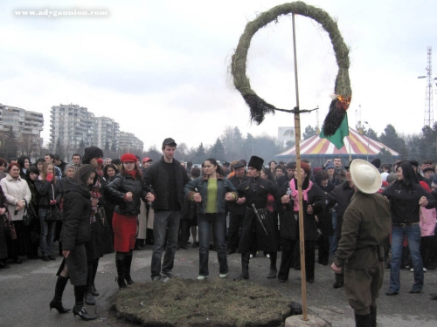
Dancing round a Fire/Cross in celebration of the
Circassian New Year, 22 March 2007 in Nalchik. The round turf represents God’s Field. The animist-cum-Christian rite is a phenomenon of the eclectic nature of the Circassian system of beliefs. The kindred Abkhazians are more avowedly animist-pagan, despite the fact that the majority are formally Christian, still clinging tenaciously to their old traditions and rituals. (Photograph courtesy of adygaunion.com)

Influence of Circassian dance melodies
on classical music

Circassian dance music influenced Russian, European, and American classical musicians in he 19th and 20th centuries. Amongst the more famous pieces composed on Circassian themes in the 19th century are: Johann Strauss’s (1825-1899) ‘Circassian March, op. 335’; (Franz) Liszt’s (1811-1886) arrangement for piano of (Mikhail Ivanovich) Glinka’s (1804-1857) ‘March of the Circassians’ (or ‘Circassian March’), from Russlan and Ludmilla; (Clément Philibert) Léo Delibes’ (1836-1891) ‘Circassian Dance’ in the ballet suite La Source (1866); Willem Vandervell’s ‘Circassia: Graceful Dance … for the pianoforte (solo and duet)’; Matthias von Holst’s (circa 1770 - circa 1850) ‘The Circassian Rondo. Rondo Circassien (composed & arranged for the pianoforte)’ (1820; J. Balls, 1811); Wilhelm Iucho’s ‘Circassian Polka, op. 113, no. 3’ (1854); Charles Louis Napoleon d’Albert’s ‘Circassian Polka for Pianoforte’ (Chappell, 1865); Theodore Bonheur’s ‘Circassian Dance for the Pianoforte’ (Francis, Day & Hunter, 1892); Kuhe Lindoff’s ‘The Circassian Polkas: Arranged as Duets for Two Performers on the Pianoforte’ (1848); Robert Dyke’s arrangement of ‘Circassian Circle: Fife and Drum Band Parts’ (1885); and J. Rivie’s ‘Circassian Quick March: Bugle Band Parts’ (1877).

The number of music pieces composed on Circassian themes dropped significantly in the 20th century in the West due to the dispersion of the majority of Circassians in consequence of the Circassian-Russian War and the Iron Curtain that cut off the remaining Circassians from the rest of the civilised world. An example of compositions in this period include Percy Elliot’s Three Pieces for the Piano [No. 1: Beau Brummel; No. 2: Asphodel; No. 3: The Circassian Dancer] (Reynolds & Co, 1928).

In contrast, Soviet music composers wrote many classical pieces on Circassian dance themes. In 1932, I. K. Shaposhnikov (1896-1953) composed ‘Kabardian Dance for Symphony Orchestra’. In 1936, Arseni R. Abraamov (1886-1944) wrote two melodies ‘Qafe’ and ‘Yislhemey’ for symphony orchestra, Kabardian Symphonic Dances, and the popular ‘Kabardian March for Wind Orchestra’.

Despite the untold hardships borne by the people during World War II, it proved to be a great boon for the development of Circassian classical music. In the summer of 1942, the Soviet Government decided to transfer some of its best musicians, actors, artists and professors from Moscow to the relative safety of Kabarda. The musicians included Sergei Prokofiev, Nikolai Ya. Myaskovsky, Vasily V. Nechaev and Anatoly N. Aleksandrov, and many others.

It was there, in the primordial beauty and serenity of Kabarda, that Prokofiev got in touch with, and became enamoured with the folk music of the Circassians. According to him, ‘Kabardian dances and songs are a goldmine of musical material.’ Prokofiev’s sojourn in Kabarda proved very productive, composing his String Quartet No. 2 in F Major Op. 92 (On Kabardian Themes), in Nalchik in about five weeks in 1942. His aim was to achieve ‘a combination of virtually untouched folk material and the most classical of classical forms, the string quartet.’ The three movements were based on actual folk songs and dances, with the original harmonies and rhythms, and without musical adornments. In spite of running foul of the official critics, the work proved an immediate success when it was premiered by the famous Beethoven Quartet in Moscow on 5 September 1942.

The first movement (‘Allegro sostenuto’) was based on the ancient dance, Udzh Starikov, or Wijizch (уджыжь), heard at the beginning and on the song ‘Sosriqwe’ («Сосрыкъуэ»), in which three players create an accordion-like accompaniment to the song, sung by the violin. The second movement (‘Adagio’) was based on a Kabardian love song, ‘Synilyaklik Zhir’, sung by the cello in a high voice. The middle section, based on the folk dance ‘Yislhemey’ is in imitation of the sound of the Circassian fiddle. The movement ends with a brief return of the opening song. The third movement (‘Allegro’) was based on a traditional mountain melody known as ‘Getegezhev Ogurbi’ («ДЖЭТЭГЪЭЖЬХЭ IЭГЪУРБИЙ»; Jeteghezchxe ’Eghwrbiy), alternating with two lyrical themes and a reminiscence of the first movement.

In 1946, on the 25th anniversary of the establishment of the Kabardian ASSR, Sergei N. Ryauzov (1905-1983) composed a symphonic suite based on three dances ‘Qafe’, ‘Yislhemey’ and ‘Wij’, which adhered closely to the original themes. In 1949, Truvor K. Sheibler (1900-1960) composed Kabardian Dance Melody: A Suite for Symphony Orchestra. Fyodor A. Silyakhin (b. 1912) wrote Kabardian Dances in 1950. Artemi G. Shakhgaldian (b. 1910) composed Qafe: Pieces for Woodwind Instrumental Quartet (1961).

Circassian classical composers who wrote classical dance pieces based on Circassian dance themes include Hesen Y. Qarden (Къардэн; Kardanov) (b. 1923), who wrote Three Symphonic Dances in 1960; Muhediyn F’. Bale (Балэ; Balov) (1923-1984), who composed Five Symphonic Dances, based on Kabardian, Adigean, Cherkess, Balkarian and Karachai melodies in 1961; Boris H. Teimirqan (Темыркъан; Temirkanov), who issued Pieces for Symphony Orchestra and National Accordion on Themes of the Music of the Peoples of the Caucasus in 1989; and Cherkess composer Aslhen Dawir (Даур Аслъэн; Aslan Daurov) (1940-1999), who wrote the symphony The Circassians, Mountain Symphonic Dances in 1983.

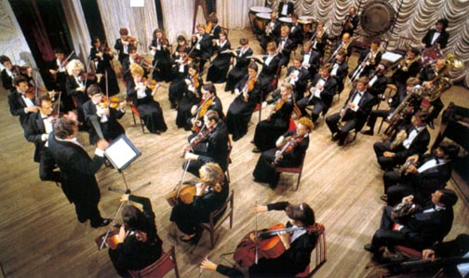
Symphony Orchestra in Adigea. (The Republic of Adygea, p19)

Traditional Circassian Dance Party
АДЫГЭ ДЖЭГУ

Partakers in a dance ceremony (джэгу; jegw) divided into two groups on the edge of the dance-floor, males on one side, females on the other. Music and song were supplied by the bards (джэгуакIуэ; jegwak’we). No one was allowed to sit while the dance was in progress, no matter how long it lasted. The two groups provided background and choral singing, but only the members of the male group clapped their hands in rhythm with the music. In the olden days, a bowl of «махъсмымэ» (makhsima) was passed round. The management of each group was assigned to a specialized class of individuals called «хьэтиякIуэ» (‘hetiyyak’we’), masters of (the dance) ceremonies, who were given presents for their work. If present at the guest quarters, professional bards took up the role of masters of ceremonies. Among the tasks of the master of ceremonies was to pick and match the dancers by pointing his decorated staff («хьэтиякIуэ баш»; hetiyyak’we bash).

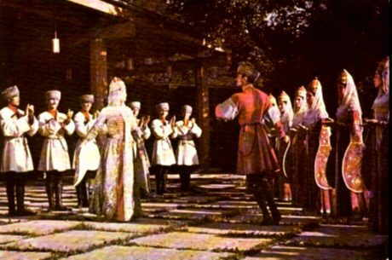
Circassian dance party.

A dance party was started with the stately slow dance «къафэ» (qafe), and ended with the solemn round dance «удж» (wij), in accordance with the saying, «Джэгур къафэкIэ къыщIадзэри, уджкIэ яух» (‘Jegwr qafech’e qisch’adzeriy, wijch’e yawix’) [‘A dance party is started with «къафэ» (qafe), and ended with «удж» (wij)’]. Male dancers had to follow the moves of their female partners and harmonize with them. A female dancer always stayed on the right of her partner, and never associated with dancers of lesser social rank. When a prince joined a dance party and took the floor, the bards paid deference to his noble demeanour by playing songs associated with his family and lineage, clapping and chorus assuming more sober and measured rhythms.

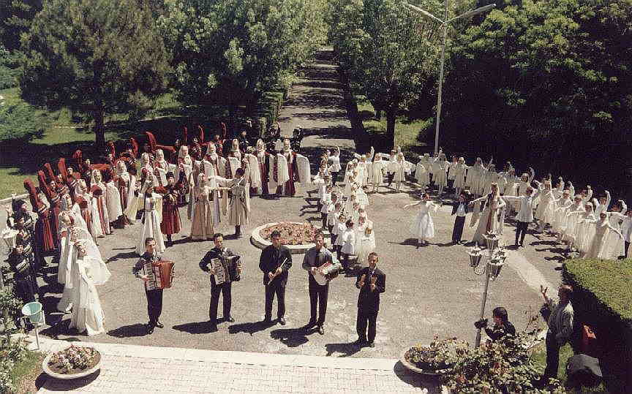
Stylised depiction of Circassian dance party.

Dance troupes

In the Soviet period, national dance academies were established. Traditional dance was modernized and professional choreography introduced. At first, the main institute specializing in Caucasian dance and choreography was the Tbilisi State Dancing College in Georgia. Circassian graduates went on to establish national troupes in their republics. Later, institutes were set up in Kabardino-Balkaria and Adigea, like the Professional Art College in Nalchik, which spawned a number of dance troupes.

The Kabardian Dance Ensemble, one of the first national troupes, was established in 1934. It started out as an amateur group, and attracted the best local dancers and musicians. The debut of the troupe was performed in the village of Zeyiqwe in the same year. The troupe was re-named the Kabardino-Balkarian State Song and Dance Ensemble. Arseni R. Abraamov developed part of its repertoire. In 1938, a choral group was added to the Ensemble, for which the cream of the republican musicians and poets, Abraamov, Truvor K. Sheibler, Ryauzov, Alim Ch’ischoqwe (Keshokov) and Ali Schojents’ik’w, combined to write new songs. The troupe was again re-named the National Folk Dance Ensemble ‘Kabardinka’. The current official name of the troupe is ‘Kabardinka Academic Dance Ensemble’. It is considered one of the finest dance troupes in the Caucasus, and has performed in the Russian Federation and abroad. Its repertoire includes many traditional dances with developed choreographs. These convey reserved inner temperament, majestic beauty and elegance—literally enchanting the spectators.

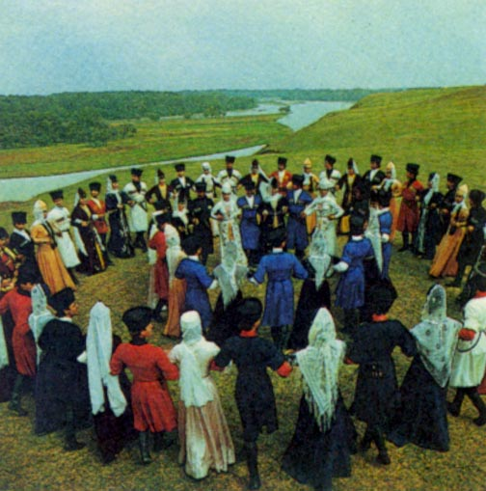
Kabardinka performing ‘wij’ in open air under the Kabardian sky.
Ancient Circassians would have proceeded to the forest
across the river and danced round a venerable arbor.
Ritual dances were mainly performed in sacred groves and
round people struck (hallowed) by lightening. (V. Vorokov, 1987, p175)

The debut of the State Dance Ensemble of Adigea took place on 1 May 1972 on the stage of the Pushkin Drama Theatre. Mahmud Beshkok, Honoured Artist of the Russian Soviet Federal Socialist Republic, was one of the more influential choreographers. He published a book on Adigean folkloric dance in 1990. Another troupe of note is the Adigean State Academic Folk Dance Ensemble ‘Nalmes’, a folk song and dance group which was set up in the early 1970s, although it was first established in the 1930s, but was later dissolved.

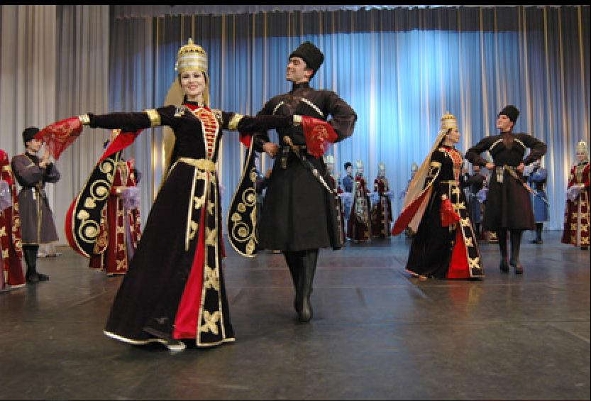
The Adigean State Academic Folk Dance Ensemble ‘Nalmes’.
Established in 1936, ‘Nalmes’ sees itself as ‘the collector,
guardian, and interpreter of Adigean folk music and dancing’.

The ‘vocalic’ component of Nalmes separated in 1991 to form the Adigean State Folk Song Ensemble ‘Yislhamiy’. ‘Yislhamiy’ («Ислъамый») is one of a number of folk song groups that keep the old bard traditions alive. It boasts of a varied and rich repertoire of ancient and traditional songs and dances. The Ensemble’s mission also includes the rearrangement of folk songs and chants into modern formats to bestow contemporary relevance on them without sacrificing their authenticity and historical value. The Ensemble displayed its artistic wares in many festivals held in countries across Europe and Asia, and made several tours in countries where Circassian diasporas are concentrated. It celebrated its 15th anniversary in January 2006. Its founder and artistic director is Aslhencheriy Nexay, People’s Artist of the Russian Federation. The choreography of the Ensemble is designed by Viktoria Yedij. The Ensemble boasts of a number of world-class singers, including Susanna X’wak’we, Shemsudin Qwmiqw, Rim Schaw(e), and Saniyat Aghirjaneqwe (Agerzhanokova). Nevertheless, the repertoire of ‘Yisthamiy’ includes a number of classic dances. Both troupes –‘Nalmes’ and ‘Yislhamiy’ – went on tours in Russia, the Caucasus, Turkey, Syria and Jordan. The Adiga troupes introduced the world to the ancient and exotic national dances.

The Caucasus State Folk Dance Company was set up by Igor Atabiev (’Etebiy) in 1992. Atabiev represents the new generation of choreographers who combine academic excellence with folkloric flare. The troupe continues the Soviet era tradition of presenting dances from many regions of the Caucasus.

The National Dance Ensemble ‘Hetiy’ («Хьэтий»; ‘Khatti’) is a troupe of young and talented musicians and dancers, whose music, costumes, and choreography are just out of this world. Their rendition of the dance ‘Mezdegw’ («Мэздэгу») is one of the highlights of Circassian dance, showcasing very fancy and elaborate footwork. The musical director of the elegant ensemble is Zubeir Yewaz (Еуаз Зубер; Evazov), who represents the new generation of traditionalists. Yewaz studied the Circassian violin in Nalchik and has done work on collecting folk songs and melodies. He collaborated with Ziramikw Qardenghwsch’ to preserve twelve Ubykh melodies, which he personally performs. He is also the artistic director of the Sirin Ensemble, which has a repertoire of ancient and traditional songs and melodies played on authentic Circassian instruments (no accordion or baraban). These two groups play an important role in the dissemination and propagation of the Circassian musical lore amongst the young.

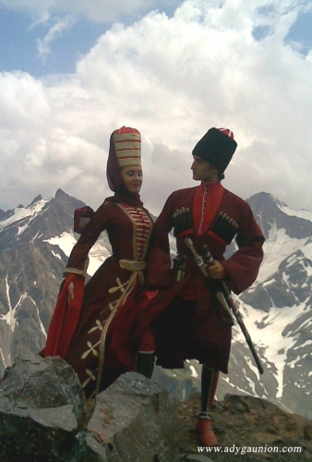
Two members of the National Dance Ensemble ‘Hetiy’ on top of
the Caucasus Mountains. (Courtesy of adygaunion.com)

Other troupes include Nalchanka, which, as the name suggests, is based in Nalchik. There are also provincial and amateur groups, like the Folk Dance Ensemble.

Bzchamiy (Бжьамий; literally: Circassian Zurna) is a Kabardian group with an impressive range of songs and dance music. It was established and is directed by Leonid Beiqwl (Bekulov), Honoured Cultural Worker of the Kabardino-Balkarian Republic. Although it does not have a dance troupe, Bzchamiy’s repertoire includes many dance tunes.

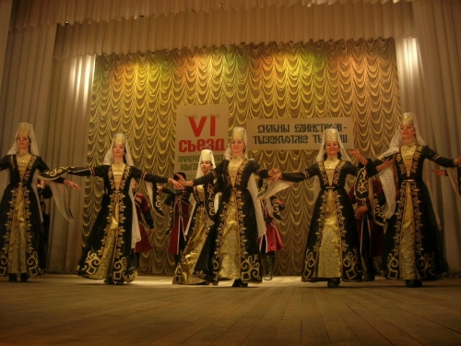
Circassian dance troupe from the Shapsugh Region of Circassia.

The repertoires of all troupes consisted of a melange of folkloric dances from various North Caucasian nationalities to reflect the multi-cultural traditions of the Soviet peoples, as was dictated by Party dogma. Graceful steps erupted into dizzying wild movements. Battle scenes were preceded by delicate dance of the warrior and his fiancée.

In the diaspora, dance is the main, and often the only, manifestation of national folklore. In many societies it is the activity most identified with Adiga culture and is readily associated with it by non-Circassians, perhaps to the detriment of other folkloric genres.

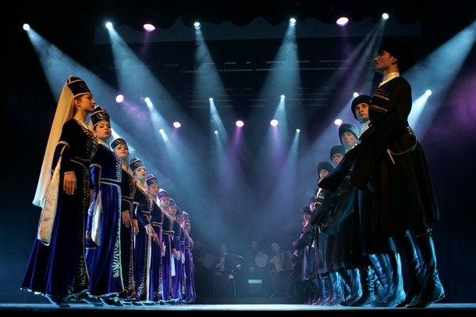
Al-Ahli Circassian Dance Troupe ‘Kuban’
performing under Royal patronage in Amman/Jordan
in March 2009.

References on Circassian dance

Beshkok, M., Adigeiski folklorni tanets [Adigean Folkloric Dances], Maikop, 1990. [Will be made available on line on this website]

Beshkok, M. I. and Nagaitseva, L. G., Adigeiski narodni tanets [Adigean Folk Dances], Maikop: Adigean Branch of the Krasnodar Book Press, 1982.

Ghwch’e, M., Adige Pshinalhexer [Circassian Melodies], Nalchik, 2006. [Dance melodies, including ‘Wij x’wrey’, ‘Gwascheghase’, ‘Dance of the Nobility’, and ‘Party Dance’; with sheet music]

Naloev (Nalo), Z. M., Rol dzheguako v natsionalnom i mezhnatsionalnom obshchenii [The Role of the Minstrels in National and International Intercourse], 1976. [Manuscript]
— ‘Dzheguako v roli hetiyyak’we [The Bard in the Role of the Master of the Dance Ceremonies]’, in Kultura i bit adigov [The Culture and Way of Life of the Circassians], The Adigean Science and Research Institute, Maikop, issue 3, 1980.

Shu, Sh. S., ‘Adigskie tantsi [Circassian Dances]’, in Sbornik statei po ètnografii Adigei [Collection of Articles on the Ethnography of Adigea], Maikop, 1975.
— ‘K voprosu o mnogogolosii v narodnom pesnopenii adigov [On the Question of Polyphony in the National Psalms of the Circassians]’, in Kultura i bit adigov [The Culture and Way of Life of the Circassians], The Adigean Science and Research Institute, Maikop, issue 6, 1986.
— Narodnie tantsi adigov [Folk Dances of the Circassians], Nalchik: Elbrus Book Press, 1992.

Sokolova, A. N., ‘The Caucasian-Scottish Relations through the Prism of the Fiddle and Dance Music’, paper presented at North Atlantic Fiddle Convention, The Elphinstone Institute, University of Aberdeen, July 2006.

The Republic of Adygea, Maikop, 1996.

Tiqwe (Tuko), Q., Circassian and Karachai Folk Songs and Dances, Cherkessk, Karachai-Cherkess Republic. [In Russian. Seminal collection of, and the reference on, folk and modern music of the Circassians in the Karachai-Cherkess Republic. The pieces are for wind orchestra, and they include such classics as ‘Adiyixw’, ‘Zefak’w’ (‘Zexwek’we’; literllay: ‘to go towards one another [so as] to meet’), ‘Qesey’, ‘Qafe’, ‘Kabardinka’, ‘Mezgwasche’, and ‘Wij’. Tiqwe, a Cherkess, is currently the President of the Union of Composers of the Republic of Adigea and is an accomplished and versatile composer and musician. He wrote about 300 folkloric and classical works, including a few opuses for traditional musical instruments. He is an ardent advocate of going back to the roots, to revive ancient music genres and present them in original forms.]

Tletseruk (Lhets’eriqwe), K. (compiler), Adige Pshinalhexer [Adigean Dance Melodies], Maikop, 1987.

Vorokov (Veroqwe), V. Kh., Kabardino-Balkariya: Photo Album, Moscow: Soviet Russia, 1987.

More on the influence of Circassian dance melodies on classical music in the West and Russia can be found below.
‘Jeteghezchxe ’Eghwrbiy yi Ghibze’ («ДЖЭТЭГЪЭЖЬХЭ IЭГЪУРБИЙ»; ‘The Elegy of ’Eghwrbiy Jeteghezch’) is a well-known Kabardian lament. Three versions of the dirge (words and music sheets) are found in V. H. Bereghwn and Z. P’. Qardenghwsch’, 1990, pp 114-20, 120-5, 425-8. Vladimir Bereghwn’s rendition of the first version (pp 114-20) is included on this webpage.
The staffs (almost sceptre-like in appearance and splendour) were about a metre long and were made from the twigs of small (forest) hazel-nut trees and were decorated with threads and golden threads, passed through equidistant openings perforated along the staff. On the staff itself, and on each of the threads, seven hazel-nuts were pinned and tied. The ends of the threads were fringed. It is markworthy that the number seven had special significance in Circassian culture. The staff served several functions, including as a baton for the master of ceremonies to conduct the orchestra.
«Къафэ» (‘Qafe’) is both a generic term for ‘dance’ and the name of a kind of dance.
In accordance with the saying, «Зэхуэмыдэ къызэдэфэкъым, зэмыфэгъу къызэдэуджкъым» (‘Zexwemide qizedefeqim, zemifeghw qizedewijqim’) [‘Those dissimilar in their social rank do not dance the «къафэ» (qafe) and «удж» (wij) together’].
The website of ‘Nalmes’ <http://www.nalmes.ru>, offered in Russian and English, has been upgraded, and is very stylish and informative.
A video file of the dance ‘Mezdegw’ by Hetiy is available on the web <http://vids.myspace.com/index.cfm?fuseaction=vids.individual&videoID=2029125517>. The Internet is full of great specimens of Circassian dancing.

