Ancient Circassian Cultures and Nations in the First Millennium BC:
Maeots, Sinds, Kerkets, Toretians, Heniokhs, etc.

[This is an expanded reworking of a section
from Amjad Jaimoukha’s The Circassians: A Handbook,
London and New York: Routledge, 2001, pp 42-5]

The Iron Age
The Iron Age in the Northwest Caucasus began in the eighth century BC. Some archaeological finds have been attributed to proto-Maeotian culture, which is dated from the eighth to seventh centuries BC. Pre-Kuban culture is attributed to the proto-Circassian Maeots (Maeotians; ‘Maeotae’ in Strabo), who inhabited the NW Caucasus and the steppes north of the Black Sea. Their civilization lasted for some 1,200 years. They maintained close relations with tribes in southeast Europe. The Maeot State was contemporaneous with the Greek colonies, which had been firmly established on the northeast coast of the Black Sea by the fifth century BC and lasted for almost a millennium. Some Greek records of this culture go back to that era.

It is thought that the origins of the North Caucasian Nart Epos go back to the time period between the Bronze Age and the Iron Age (from 12th to 8th centuries BC). The Bronze Age in Circassia shall be the subject of a subsequent article.

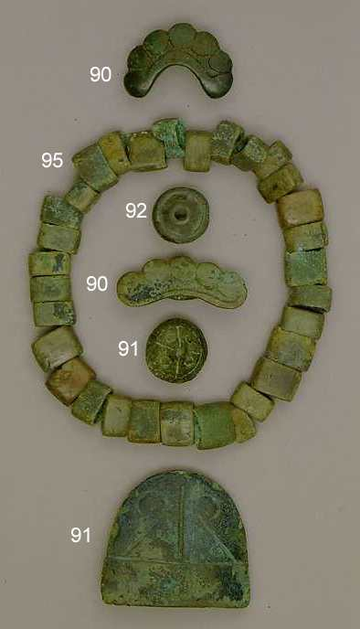
Plaques and beads of the proto-Maeotians, 8th century BC.
Adigea, stanitsa Novosvobodnaya, burial site Fars.
Bronze casting.
[State Museum of the Art of the Peoples of the Orient,
Archaeology of the Caucasus <http://www.arcaucasica.ru/index.php3?path=_art/gold_noth_caucasus/eng&source=proto_meot_culture>]

Maeots, Greeks and Iranian Tribes
The first reference to the Maeots by an ancient writer was in the sixth century BC. According to Strabo (Geography, 11.2), who wrote his account in the first half of the first century AD:

In the voyage along the coast, one comes first, at a distance of eight hundred stadia from Tanaïs [The Don River; ‘Tane’ («Танэ») in Circassian], to the Greater Rhombites River, as it is called, where are made the greatest catches of the fish that are suitable for salting. Then, at a distance of eight hundred more, to the Lesser Rhombites and a cape, which latter also has fisheries, although they are smaller. The people who live about the Greater Rhombites have small islands as bases for their fishing; but the people who carry on the business at the Lesser Rhombites are the Maeotae themselves, for the Maeotae live along the whole of this coast; and though farmers, they are no less warlike than the nomads. They are divided into several tribes, those who live near the Tanaïs being rather ferocious, but those whose territory borders on the Bosporus being more tractable... As for the Asiatic Maeotae in general, some of them were subjects of those who possessed the emporium on the Tanaïs, and the others of the Bosporians; but in those days different peoples at different times were wont to revolt.

The Maeots and the mercantile Greeks, who established colonies on the northeastern shores of the Black Sea in the fifth century BC, established trade links. The Greeks provided the Maeots with wine, olive oil, table-ware and luxury articles. The Caucasians, whose economy was agrarian in nature, reciprocated with cereal produce, meat, wool, hides, and slaves.

Close relations were also maintained with the Iranian-speaking nations, like the Cimmerians and Scythians, who inhabited the northern Black Sea regions in the west and the Sarmatians who occupied the lands between the Don and Volga. Contacts go back to the eighth century BC, as can be evidenced by similarity in weaponry and horse-riding equipment of proto-Maeots and Scythians and Cimmerians. On the geography of the Maeots (and related Northwest Caucasian nations) and Scythians, Strabo wrote the following in his Geography (11.2):

Of the portions thus divided, the first is inhabited, in the region toward the north and the ocean, by Scythian nomads and wagon-dwellers, and south of these, by Sarmatians, these too being Scythians, and by Aorsi and Siraci,1 who extend towards the south as far as the Caucasian Mountains, some being nomads and others tent-dwellers and farmers. About Lake Maeotis live the Maeotae. And on the sea lies the Asiatic side of the Bosporus, or the Syndic territory. After this latter, one comes to the Achaei and the Zygi and the Heniochi, and also the Cercetae and the Macropogones.2 And above these are situated the narrow passes of the Phtheirophagi;3 and after the Heniochi the Colchian country, which lies at the foot of the Caucasian, or Moschian, Mountains. But since I have taken the Tanaïs River as the boundary between Europe and Asia, I shall begin my detailed description therewith.

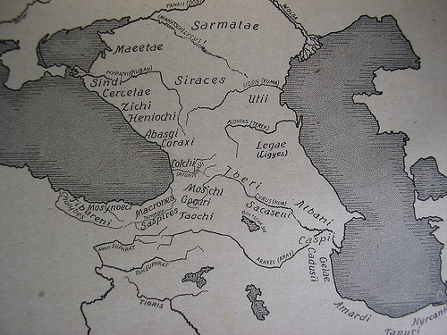
Map showing the nations of the Caucasus
in the second half of the first millennium BC.
Circassian nations in the northwest Caucasus included
(from north to south) the Maeots, Sinds, Kerkets, Zikhis, and Heniokhs.
The hinterland Circassians were pushed westwards by the
invading Iranian Siraci (Siraces) in the late fourth century BC.
Rich cultural contacts were maintained between the Maeots
and the Iranian Sarmatians (and with the Cimmerians and Scythians
in preceding centuries). The map also shows the Abasgi,
ancestors of the Abkhaz, located in an area coincident with their
present domicile, indicating that the Abkhaz have been living
in Abkhazia for thousands of years.

Mutual influences between the Caucasian and Iranian nations persisted for a long time, which fact can be corroborated by the wealth of artefacts of the Maeotian-Scythian period that goes back to late seventh to fourth centuries BC, and to the Maeotian-Sarmatian period, from the last few centuries BC to the first few centuries of our era. Archaeological finds attributed to the first period in the Kurzhips, Kostromskaya, Karagodeuashkh, and other tumuli in Circassia confirm the accounts of antique writers on both the Maeots and Scythians. Relics of the Maeotian culture are found in the museums of Adigea, Moscow, and St. Petersburg.

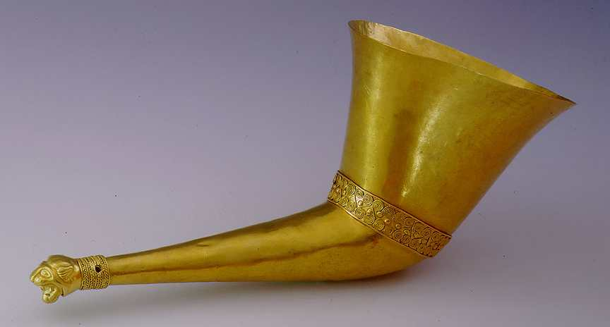
Maeotian gold rhyton (vessel for drinking or libation)
ending in a panther head, 5th century BC.
Adigea, aul Ulyap, Kurgan 4, object from ritual site.
Gold, forging, embossing, engraving, soldering, riveting.
[State Museum of the Art of the Peoples of the Orient,
Archaeology of the Caucasus <http://www.arcaucasica.ru/index.php3?path=_art/gold_noth_caucasus/eng&source=skif_period_katalog>]

Some art treasures found in Maeotian tumuli were attributed to the ancient civilizations of Egypt, Greece and Persia, suggesting cultural and mercantile contacts. The chain of contact must have passed through the Greek Black Sea ports and the inland Maeotian towns.

In 480 BC, the Greeks established the Bosporan Kingdom (Cimmerian Bosporus) on the eastern Crimea with a capital at Panticapaeum, modern-day Kerch. This unique State was ruled by Greeks and by local dynasties, mainly Maeotian and Scythian. Starting from 438 BC, when Spartocus I (who had Thracian connections) assumed power, the Kingdom pushed eastwards and subjugated the Maeotians and Sinds on the Eastern Shore of the Black Sea. The Maeotians maintained trade relations with the Bosporans. The Bosporan Kingdom was subjugated by Mithradates VI, king of Pontus in northern Anatolia, in 108/7 BC. Mithradates also subdued the Maeots, Heniokhs (Heniochi), and Achaeans (Achaei), amongst other nations, on his whirlwind tour of the Black Sea.

In the late fourth century BC, two Sarmatian tribes, the Siraci and Aorsi, made their first appearance in the steppes of the North Caucasus. Soon after, they pushed south into the Kuban and occupied the lands on the right-bank. Archaeological evidence suggests that some time later they either crossed to the left side, or else established close ties with the indigenes. The symbiosis of the Maeots and Sarmatians lasted for centuries. Maeotian cultural borrowings were found throughout the lands occupied by the Sarmatians from the Ural Mountains to the Dniester.

Kingdom of Sindika
By the fifth century BC, the Sinds (Sindi), a people kindred to the Maeots, had set up the magnificent Sindika civilization, which spread over the lower reaches of the Kuban, the Black Sea coastal strip between Anapa and Taman Peninsula, inclusive. A description of the Sinds and Sindika can be met in Efes, fourth century BC. According to Strabo (Geography, 11.2):

Sailing into Lake Corocondamitis one comes to Phanagoreia, a noteworthy city, and to Cepi, and to Hermonassa, and to Apaturum, the sanctuary of Aphrodite. Of these, Phanagoreia and Cepi are situated on the island above-mentioned, on the left as one sails in, but the other cities are on the right, across the Hypanis, in the Syndic territory. There is also a place called Gorgipia in the Syndic territory, the royal residence of the Sindi, near the sea; and also a place called Aborace... Among the Maeotae are the Sindi themselves, Dandarii, Toreatae, Agri, and Arrechi, and also the Tarpetes, Obidiaceni, Sittaceni, Dosci, and several others. Among these belong also the Aspurgiani, who live between Phanagoreia and Gorgipia, within a stretch of five hundred stadia; these were attacked by King Polemon under a pretence of friendship, but they discovered his pretence, outgeneralled him, and taking him alive killed him.

The Sindika city-state lasted for two centuries until the Bosporan Kingdom absorbed it. It achieved a high level of social and economical development, with a maritime culture. Its capital was Gorgipp(i)a, present-day Anapa, which had a large port. This splendid city was an expansion of an Ionian trading settlement built in the sixth to early fifth centuries BC. Antique writers referred it to as Sindian Harbour. It came of age in the first half of the fourth century BC and survived for seven centuries until it was gutted by an apocalyptic conflagration in the middle of the third century AD.

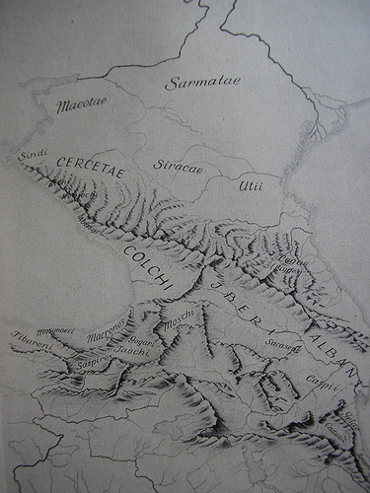
The Northwest Caucasians (Sindi, Maeotae, and Cercetae)
and the Iranian tribes (Sarmatae and Siracae) established
cultural and mercantile relations among themselves
and with the Greek colonists on the Black Sea coast
in the second half of the first millennium BC.
The mutually enriching symbiosis,
disrupted by the occasional strife for power,
lasted for centuries.
Trade occupied an important place in the economy of Sindika. Handicrafts and artefacts bear testimony to the advanced state reached by this culture. Beyond doubt the locals learnt a great deal from the Greek colonists, but gradually they developed their own artistic identity. Sind sculptures and drawings were found in Taman. G. Turchaninov (1971, 1999) analyzed texts that are attributed to the Sinds, perhaps the first records of proto-Circassian writing.

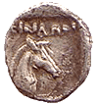
Coin minted in Sindika in the first half of the 5th century BC,
most probably during the term of tenure of Sindika King Ekatay.
There is a bust of Hercules on one side and a horse’s head on the other,
with the legend of ‘ΣΙΝΔΩΝ’ (‘Sindon’).
Coins from Sindika are very rare indeed.
[Courtesy of ‘The Odessa Virtual Museum of Numismatics’
<http://www.museum.com.ua/en/istor/sev-vost/sev-vost.htm#3>]

According to the Macedonian author Polyaenus of the second century AD, the king of the Sinds, Ekatay (Hecataeus), was deposed. Satyrus I, King of the Bosporan Kingdom (from 431 to 387 BC), restored him to the throne and gave him his daughter for marriage to cement their alliance. He stipulated that Ekatay must kill his first wife, Tirghetau (Tirgatao), queen of the Sinds and daughter of the Maeot king. Caught between the hammer and anvil, Ekatay chose to imprison his ex-wife, rather than face the ire of the mighty Maeots. Tirghetau used her cunning to escape. She married her father’s successor and convinced him to wage war against the Sinds and Bosporans. The Maeot army devastated Sindika and upon reaching Bosporas, Satyrus and Ekatay entreated for peace. Satyrus handed over his son Mithradates as a pledge. After a failed attempt on her life, Princess Tirghetau raised and led an army, which defeated Satyrus around 400 BC. The tyrant took his own life. His successor sent many gifts to the Princess and pledged his allegiance. Circassian folklore still keeps memory of this indomitable female-warrior.

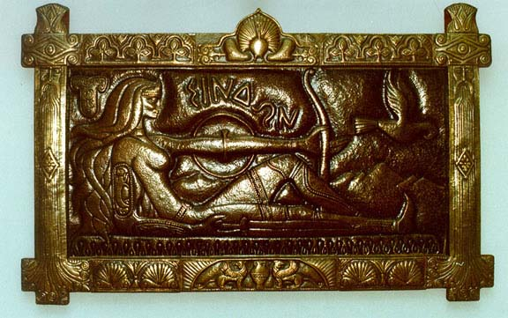
Depiction of Queen Tirghetau (Tirgatao)
by the Kabardian writer and artist Boris ’Wt’izh.
[Courtesy of Hasan Jurt <http://www.kabardey.narod.ru/>]

Roughly in the middle of the fourth century BC, Gorgippus, after whom the Sindika Capital was named, incorporated the Sinds into the Bosporan Kingdom.

Northwest Caucasian Nations
Scylax (Scylacis Caryand), who journeyed along the Black Sea coast in the sixth century BC, provided a description of the peoples of the NW Caucasus including the Maeots and Sinds. According to him, the Kerkets (Cercetae), the ancestors of the Zyghoy (Zygi), lived in the strip of coastal land between Anapa and Ghelenjik. The Achaeans, who lived between the Kerkets and Heniokhs, roughly in the area around present-day Sochi, were the neighbours of the Bosporan Kingdom, which dominated some Circassian tribes.

Other nation-tribes included the Toretians who occupied lands to the south of the Sinds, the Dandari(i) and Tarpeti on the eastern shore of the Sea of Azov, the Psessi and Thatei who occupied the upper reaches of the Kuban and its tributaries, perhaps as far as the Laba. The picture was completed by the Heniokhs, who formed a mighty mercantile state in the area just north of the land of the Abasgi, present-day Abkhazia, and the Colchians. Scylax was the first to mention the Kerkets, which name, together with Sinds, was also mentioned in Orpheus’ poem ‘The Argonauts’ almost 2,500 years ago. Archaeological finds give credence to the theory that all NW Caucasian peoples, the Maeots, Sinds, Kerkets, Toretians, Heniokhs, and Abasgi, were ethnically and linguistically related and that they were the ancestors of the Circassians and Abkhazians.

The Roman Era
A subsequent hiatus extends well into Roman hegemony on the Eastern Coast of the Black Sea in 64 BC. In 65 AD, Mithradates escaped his vanquisher, Pompei, and spent the winter in Dioscurias, modern-day Sukhumi. He then travelled along the coast of ancient Circassia. According to him, the Heniokhs had four kings. It was Strabo in 26 AD who first mentioned the name Zyghoy, which replaced the old appellation Kerket. In his account, the Achaeans and Heniokhs maintain their states, but the Kerkets are replaced by the Zyghoys, their descendants. These nations had small sea vessels that could carry about twenty people, which the Greeks called camaras (or q’wafe in Circassian):

After the Sindic territory and Gorgipia, on the sea, one comes to the coast of the Achaei and the Zygi and the Heniochi, which for the most part is harborless and mountainous, being a part of the Caucasus. These peoples live by robberies at sea. Their boats are slender, narrow, and light, holding only about twenty-five people, though in rare cases they can hold thirty in all; the Greeks call them ‘camarae.’12 They say that the Phthiotic Achaei [13] in Jason's crew settled in this Achaea, but the Laconians in Heniochia, the leaders of the latter being Rhecas14 and Amphistratus, the ‘Heniochi’15 of the Dioscuri,16 and that in all probability the Heniochi were named after these. At any rate, by equipping fleets of ‘camarae’ and sailing sometimes against merchant vessels and sometimes against a country or even a city, they hold the mastery of the sea. And they are sometimes assisted even by those who hold the Bosporus, the latter supplying them with mooring places, with market place, and with means of disposing of their booty. And since, when they return to their own land, they have no anchorage, they put the ‘camarae’ on their shoulders and carry them to the forests where they live and where they till a poor soil. And they bring the ‘camarae’ down to the shore again when the time for navigation comes. And they do the same thing in the countries of others, for they are well acquainted with wooded places; and in these they first hide their ‘camarae’ and then themselves wander on foot night and day for the sake of kidnapping people. But they readily offer to release their captives for ransom, informing their relatives after they have put out to sea. Now in those places which are ruled by local chieftains the rulers go to the aid of those who are wronged, often attacking and bringing back the ‘camarae,’ men and all. But the territory that is subject to the Romans affords but little aid, because of the negligence of the governors who are sent there. Such is the life of these people. They are governed by chieftains called ‘sceptuchi,’17 but the ‘sceptuchi’ themselves are subject to tyrants or kings. For instance, the Heniochi had four kings at the time when Mithridates Eupator,18 in flight from the country of his ancestors to the Bosporus, passed through their country; and while he found this country passable, yet he despaired of going through that of the Zygi, both because of the ruggedness of it and because of the ferocity of the inhabitants; and only with difficulty could he go along the coast, most of the way marching on the edge of the sea, until he arrived at the country of the Achaei; and, welcomed by these, he completed his journey from Phasis, a journey not far short of four thousand stadia. Now the voyage from Corocondame is straight towards the east; and at a distance of one hundred and eighty stadia is the Sindic harbor and city; and then, at a distance of four hundred stadia, one comes to Bata, as it is called, a village and harbor, at which place Sinope on the south is thought to lie almost directly opposite this coast, just as Carambis has been referred to as opposite Criumetopon.19 After Bata Artemidorus20 mentions the coast of the Cercetae, with its mooring places and villages, extending thence about eight hundred and fifty stadia; and then the coast of the Achaei, five hundred stadia; and then that of the Heniochi, one thousand; and then Greater Pityus, extending three hundred and sixty stadia to Dioscurias. The more trustworthy historians of the Mithridatic wars name the Achaei first, then the Zygi, then the Heniochi, and then the Cercetae and Moschi and Colchi, and the Phtheirophagi who live above these three peoples, and the Soanes, and other small tribes that live in the neighborhood of the Caucasus. Now at first the coast, as I have said, stretches towards the east and faces the south, but from Bata it gradually takes a turn, and then faces the west and ends at Pityus and Dioscurias; for these places border on the above-mentioned coast of Colchis. After Dioscurias comes the remaining coast of Colchis and the adjacent coast of Trapezus, which makes a considerable bend, and then, extending approximately in a straight line, forms the righthand side of the Pontus, which faces the north. The whole of the coast of the Achaei and of the other peoples as far as Dioscurias and of the places that lie in a straight line towards the south in the interior lie at the foot of the Caucasus. — Strabo, Geography (11.2).

In the second century AD the Roman traveller, Arrian(i) (ca. 86-after 146), recorded the presence of the Sanighs, the Abaski and the Apsiles, in place of their forebears the Heniokhs. These three nation-tribes were undoubtedly the forebears of the present-day Abkhaz and Abaza. The Zyghoy and Achaeans were replaced by the Zikhis, their progeny. All these peoples were under Roman domination, the emperor appointing the four reigning kings.

References & Bibliography

Abercromby, John, ‘An Amazonian Custom in the Caucasus’, in Folklore, vol. 2, no. 2, June 1891, pp 171-81.
Academy of Sciences of the USSR, Narti: Kabardinski èpos [The Narts: A Kabardian Epos], Moscow, 1951; second edition: 1957.
Arriani, Ponti Euxini et Maris Erythraei Periplus, ad Adrianum Caesarem, Genev., 1577. [Arriani undertook his voyage in 110 AD]
Ascherson, Neal, Black Sea: The Birthplace of Civilisation and Barbarism, London: Jonathan Cape, 1995; Vintage, 1996; New York: Hill and Wang, 1996.
Bennett, Florence Mary, Religious Cults Associated With the Amazons, New York: Columbia University Press, 1912. Online. Available HTTP: <http://www.sacred-texts.com/wmn/rca/index.htm> (accessed 30 September 2008).
Colarusso, John, ‘Myths from the Forests of Circassia’, in The World & I, December, 1989, pp 644-51. Online. Available HTTP: <http://www.circassianworld.com/colarusso_3.html> (accessed 20 January 2009).
Colarusso, John, ‘Peoples of the Caucasus’, in Encyclopedia of Cultures and Daily Life, Pepper Pike, Ohio: Eastword Publications, 1997. Online. Available HTTP: <http://www.circassianworld.com/colarusso_2.html> (accessed 20 January 2009).
Èrlikh, V., Северо-Западный Кавказ в начале железного века: протомеотская группа памятников [The Northwest Caucasus at the Beginning of the Early Iron Age: The Proto-Meotian Group of Monuments], Moscow: Nauka, 2007. [A summary in English is available at <http://www.arcaucasica.ru/index.php3?path=_english/summares_books&source=erlikh_northwest_caucasus>]
‘Gold of the North Caucasus’, State Museum of the Art of the Peoples of the Orient, Archaeology of the Caucasus <http://www.arcaucasica.ru/index.php3?path=_art/gold_noth_caucasus/eng&source=entrance>.
Herodotus, The History of Herodotus, 440 BC. Translated by George Rawlinson. Provided by The Internet Classics Archive. Online. Available HTTP: <http://classics.mit.edu/Herodotus/history.mb.txt> (accessed 20 January 2009).
Hind, J. G. F., ‘The Bosporan Kingdom’, in D. M. Lewis, John Boardman, Simon Hornblower and M. Ostwald (eds), The Fourth Century B.C., Volume 6 in ‘The Cambridge Ancient History’ Series, Cambridge University Press, 1994. Online. Available HTTP: <http://histories.cambridge.org/extract?id=chol9780521233484_CHOL9780521233484A019> (accessed 19 January 2009).
Jaffarov, Y., ‘The Gargar Problem and Emerging of Writing in Caucasian Albania’, paper presented at Annual Conference of the Central Eurasian Studies Society, 2001.
Jaimoukha, Amjad, The Circassians: A Handbook, London: RoutledgeCurzon (Taylor & Francis); New York: Palgrave and Routledge, 2001.
— The Chechens: A Handbook, New York: Routledge; London: RoutledgeCurzon (Taylor & Francis), 2005.
— ‘Circassian Corsets, … a Fashion Craze, Amazons, Disposable Body Parts, and Ancient Circassians: A Quaint Tale Told in Quotes’, October 2008. <http://www.geocities.com/jaimoukha/Circassian_Corsets_and_Amazons.html>
— Circassian Culture and Folklore: Hospitality Traditions, Cuisine, Festivals & Music (Kabardian, Cherkess, Adigean, Shapsugh & Diaspora), London and New York: Bennett and Bloom, 2009.
Kantorovich, A. R. and Èrlikh, V. R., Бронзолитейное искусство VIII-III вв. до н.э. из курганов Адыгеи [Bronze-Casting Art of the VIII-III Centuries BC from the Tumuli of Adigea], Moscow: State Museum of the Art of the Peoples of the Orient, 2006.
Klaproth, J. (von), Travels in the Caucasus and Georgia, Performed in the Years 1807 and 1808, London: Henry Colburn, 1814.
Kovalevsky, M. [M.], ‘La famille matriarcale au Caucase’, in L’Anthropologie, vol. 4, 1893, pp 259-78.
Leskov, A. M. and Lapushnian, V. L. (eds), Art Treasures of Ancient Kuban, Moscow: Ministry of Culture of the USSR, Adighe Museum of Local History, etc., 1987. [In English and Russian. Good historical introduction by Leskov. This is a seminal book on the ancient art treasures of the Maeots, ancestors of the Circassians]
Meoti: Predki adigov [The Maeots: Ancestors of the Circassians], Maikop, 1989.
Mill, John Stuart, ‘Appendix B: The Vixen, and Circassia, April 1837’, in The Collected Works of John Stuart Mill, Volume XXXI – Miscellaneous Writings [1827], edited by John M. Robson, Toronto: University of Toronto Press; London: Routledge and Kegan Paul, 1989. Online. Available HTTP: <http://oll.libertyfund.org/?option=com_staticxt&staticfile=show.php%3Ftitle=238&chapter=53609&layout=html&Itemid=27> (accessed 20 January 2009).
Namitok (Nemitiqw), Aytek, Origines des Circassiens [The Origins of the Circassians], Paris: Librairie Orientaliste Paul Geuthner, 1939.
Polyaenus, Strategems in War, translated to English by E. Shepherd, London, 1793.
Rjabchikov, Sergei V., Drevnie texti slavyan i adigov [The Ancient Texts of the Slavs and Circassians], Krasnodar: Torgovo-promyshlennaya palata Krasnodarskogo kraya [The Chamber of Commerce and Industry of the Krasnodar Krai], 1998.
— ‘The Scythians, Sarmatians, Meotians, Russians and Circassians: Interpretation of the Ancient Cultures’, in The Slavonic Antiquity, 1999. Online. Available HTTP: <http://public.kubsu.ru/~usr02898/sl2.htm> (accessed 20 January 2009).
Scylacis Caryand, Periplus, Augustae Vindel, 1600.
Scylax de Caryanda, Jacobus Gronovius, Scylax, Agathemerus, Isaac Vossius, Jacob Palmerius, Jacques Le Paulmier, Samuel Tennulius, Geographica antiqua, hoc est Scylacis Periplus maris mediterranei. Anonymi Periplus Maeotidis paludis et Ponti Euxini. Agathemeri Hypotyposis geographiae. Omnia Graeco-Latina. Anonymi Expositio totius Mundo Latina: hoc est: Scylacis, Periplus Maris Mediterranei: Anonymi, Periplus maeotidis ..., J. Luchtmans, 1697. [Downloadable from Google Books]
Shapiro, H. A., ‘Amazons, Thracians, and Scythians’, in Greek, Roman, and Byzantine Studies, vol. 24, 1983, pp 105-14.
Spencer, Edmund, Travels in Circassia, Krim Tartary, & C. Including a Steam Voyage down the Danube, from Vienna to Constantinople and round the Black Sea, in 1836, London: Henry Colburn, 1837. Online. Available HTTP: <http://www.circassianworld.com/Edmund_Spencer.html> (accessed 20 January 2009). [Also available on Google Books]
Strabo, De situ orbis, Basil., 1549.
— The Geography of Strabo, Literally translated, with notes, in three volumes, London: George Bell & Sons, 1903. Online. Available HTTP: <http://www.perseus.tufts.edu/hopper/text.jsp?doc=Perseus:text:1999.01.0239&default.scheme=book:chapter:section&default.type=book> (accessed 20 January 2009).
— The Geography of Strabo, New York: G. P. Putnam Co., 1932.
Takho-Godi, A. A., ‘Amazonki’, in S. A. Tokarev (ed.), Mifi narodov mira, vol. 1, Sovetskaya Èntsiklopediya [Soviet Encyclopædia], Moscow, 1991, pp 63-4. Online. Available HTTP: <http://ec-dejavu.ru/a/Amazons.html> (accessed 20 January 2009).
Turchaninov, G. F. (Г. Ф. Турчанинов), ‘Письменные памятники средневековой Кабарды’ [‘Writing Monuments of Mediæval Kabarda’], in Kabardian Truth (Newspaper), 19 May 1946.
— ‘Памятники письма и языка народов Кавказа и Восточной Европы’ [‘Monuments of the Writing and Language of the Peoples of the North Caucasus and Eastern Europe’], Leningrad, 1971.
— Открытие и дешифровка древнейшей письменности Кавказа [Discovery and Decipherment of the Ancient Written Languages of the Caucasus], Мoscow, 1999.
Ustinova, Y[u]., The Supreme Gods of the Bosporan Kingdom: Celestial Aphrodite and the Most High God, BRILL, 1999. [Available for preview on Google Books]

For an exhibition of artefacts of the proto-Maeotian civilization, refer to ‘Gold of the North Caucasus’, State Museum of the Art of the Peoples of the Orient, Archaeology of the Caucasus <http://www.arcaucasica.ru/index.php3?path=_art/gold_noth_caucasus/eng&source=proto_meot_culture>.
In some sources the Maeots are ascribed an Iranian origin (as in Y[u]. Ustinova, 1999). This stems from their close association with their Iranian neighbours, the Scythians and Sarmatians. The Maeots were the indigenous population of the Northwest Caucasus, preceding the Iranian Cimmerians, Scythians and Sarmatians by millennia, and speaking a Northwest Caucasian language ancestral to Circassian.
Yuri Libedinsky in Preface to Narti: Kabardinski èpos [The Narts: A Kabardian Epos], Moscow: Academy of Sciences of the USSR, 1951; pp 8-18.
For an exhibition of artefacts of the Maeotian culture, refer to ‘Gold of the North Caucasus’, State Museum of the Art of the Peoples of the Orient, Archaeology of the Caucasus <http://www.arcaucasica.ru/index.php3?path=_art/gold_noth_caucasus/eng&source=skif_period_katalog>.
See A. M. Leskov and V. L. Lapushnian (eds), 1987. The book features high definition photographs of the art treasures of the Maeotians and Sinds, amongst other peoples.
There are fascinating accounts of the Bosporan Kingdom and the interaction of the Greeks on the northeastern shores of the Black Sea with native Northwest Caucasians and Iranian invaders in Neal Ascherson, 1995. The Amazons also get a fair covering in this work (pp 111-24).
A well-preserved silver coin minted in Sindika was found in 1830 in the Island of Taman, with a bust of Hercules on one side and a horse’s head on the other with the legend of ‘ΣΙΝΔΩΝ’ (‘Sindon’). — ‘Numismatic Discoveries’, The London Literary Gazette and Journal of Belles Lettres, Arts, Sciences, Etc, London: H. Colburn, 1831, p524.
Polyaenus’ work Strategems in War was translated to English by E. Shepherd and published in 1793.
The Circassian writer Boris ’Wt’izh (IутIж Борис; 1940-2008) wrote a play on the theme of Tirghetau (Тыргъэтау) in 1973-5. It was staged in 1977 and 1990.
For detailed analysis of historical sources on ancient Circassian nations in the Iron Age, refer to Aytek Namitok, 1939.
According to Strabo (Geography): ‘[The Bosporan King] Pharnaces is said at one time actually to have conducted the Hypanis River over the country of the Dandarii through an old canal which he cleared out, and to have inundated the country.’
Arriani undertook his voyage in 110 AD.

